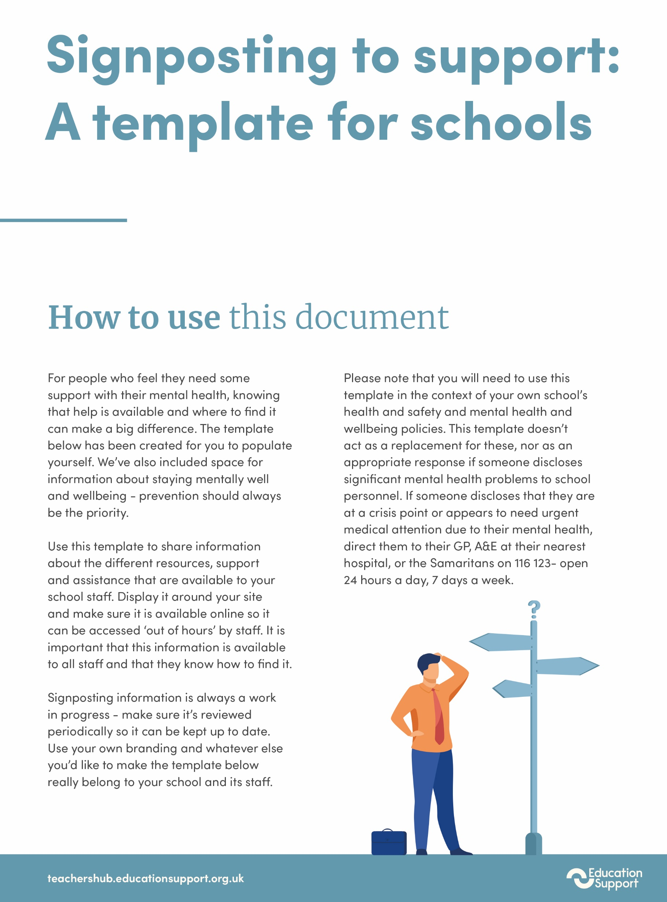

­

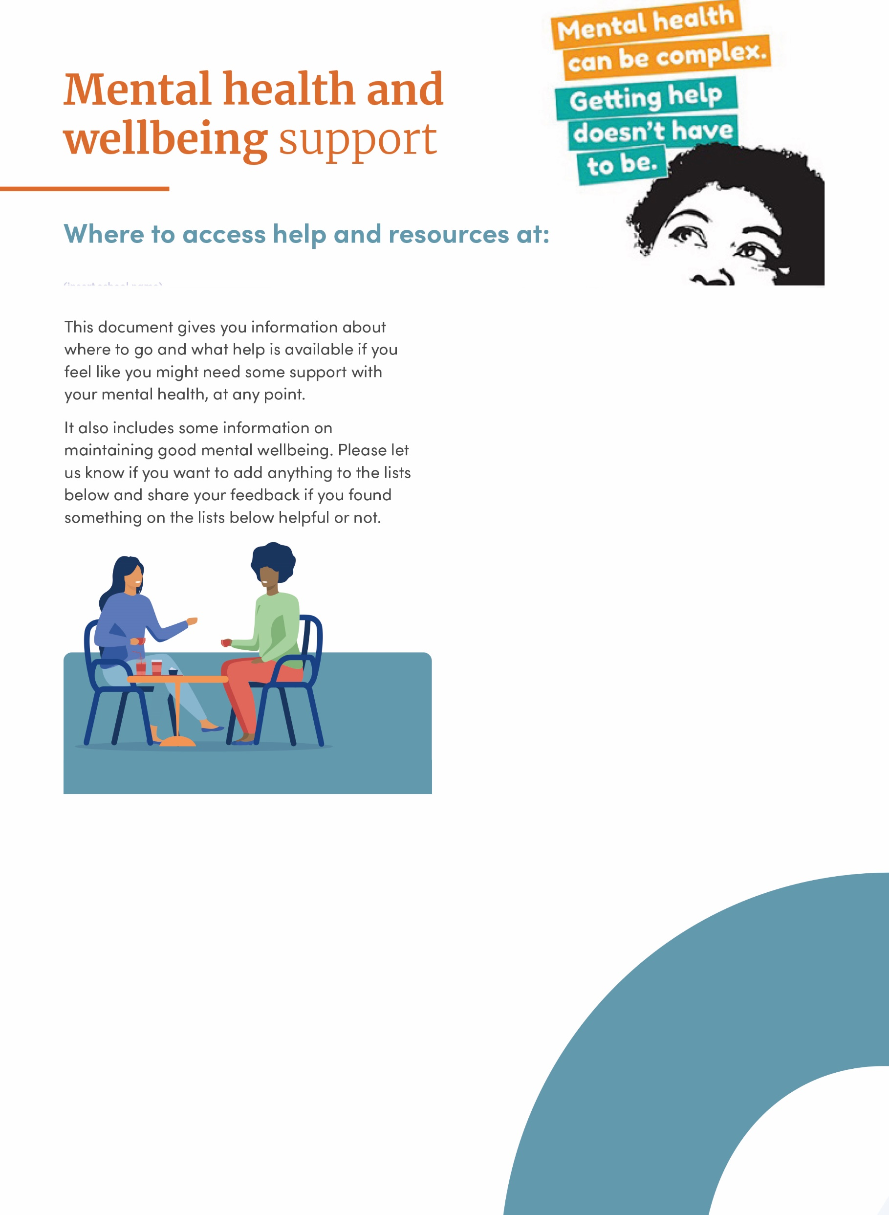­­­

**Insert your school name here**

Maintaining good mental health and wellbeing - what’s available at school:

 Add in any details of exercise, resilience, meditation, mindfulness or stress management sessions or classes that are available through school

 Give details of any wellbeing committee or function the school has and activities they plan with a contact for people if they want to get involved

 Include a link to your school’s mental health and wellbeing policy, plan or framework if you have one

 You could also include any of the following   
(or similar) links:

* [5 ways to wellbeing](https://www.mindkit.org.uk/5-ways-to-wellbeing/)
* [Mental Health Foundation’s top 10 wellbeing tips](https://www.mentalhealth.org.uk/publications/how-to-mental-health?gclid=Cj0KCQiA1pyCBhCtARIsAHaY_5eCOt9XZu0XE7XXY_HTuemlEALR4sTvBkBwHkx_Riih86TDSO6zTesaAqdGEALw_wcB)
* [Mind’s wellbeing advice](https://www.mind.org.uk/information-support/tips-for-everyday-living/wellbeing/wellbeing/)
* Section six of this hub: Providing tools and support to all staff, including those living with a mental health problem.

Resources and support available through school:

 Add in details of any support you offer to school staff e.g. an employee assistance programme, access to counselling services, HR support services, mental health first aiders

 Make sure you include clear and accurate information about how to access the services and support e.g. including opening hours, phone numbers, office hours etc.

 Signpost to online resources or information that your school has on mental health and wellbeing. e.g. stress reduction tips

­­

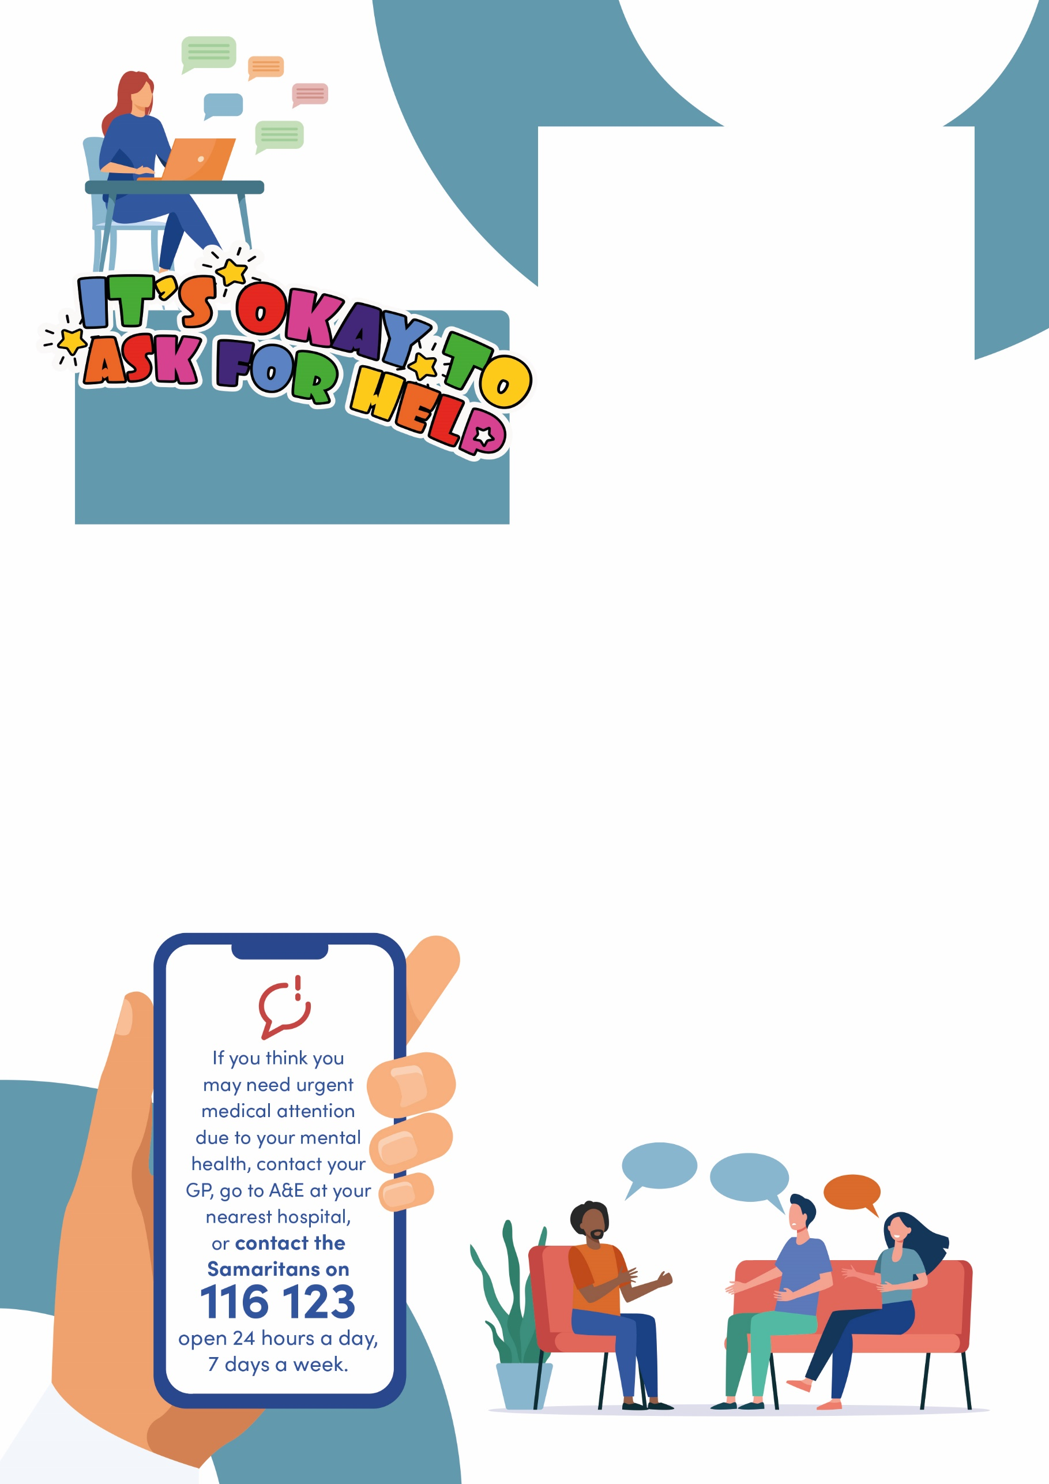

**National helplines   
and other services:**

If you also want to signpost to national   
support lines this is the place to do that   
and here are some of the services you   
could chose to include:

 **Education Support**   
24/7 confidential helpline  
Phone 08000 562 561   
www.educationsupport.org.uk

 **Samaritans**   
Phone 0116 123 or jo@samaritans.org   
www.samaritans.org

 **Mind Infoline**  
Phone 0300 123 3393 or text 86463  
info@mind.org.uk   
www.mind.org.uk/information-support/helplines

 **Rethink Mental Illness Advice Line**  
Phone 0300 5000 927  
email: advice@rethink.org  
www.rethink.org/about-us/our-mental-health-advice

 **Saneline** - Phone 0300 304 7000  
ww.sane.org.uk

 **Side by Side** peer support online   
sidebyside.mind.org.uk/about

 SHOUT - 24/7 text service text: 85258  
www.giveusashout.org

**Local resources & support:**

— Your local community will likely have a wide range of different services for people needing support with their mental health.

— This might include things like provision offered by your local Mind, your local Rethink support group, peer support services in the community, or other local projects that aim to help people with their mental health.

— You should be able to find this information using local NHS, local authority, and charity and voluntary sector websites.